2022 BATH HALF
PLEDGE FORM

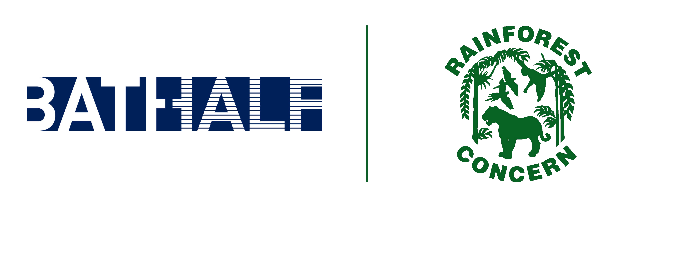
If you would like to apply for a place to run for Rainforest Concern in the Bath Half Marathon, and you are confident that you can raise £300 then please complete the following details.
*Payment of the £50 non-refundable entry fee will secure your place.
Please read ‘Information’ on the last page of this form before sending it to us.

About You:
Name: Title:
Address:

Postcode:
Tel Home:
Email:

Social Media (optional)
Twitter:

Employment Information

Mobile:
Date of Birth:

Instagram:

Job Title:
Does your company offer matched funding?

T-shirt size (XS, S, M, L, XL):

Have you been in touch with Rainforest Concern before?

In addition to the details above, we would like to know a little more about you.
Have you ever run a Marathon before? If yes, was this for a charity?

How will you prepare for the event so that you are able to complete the run?

Have you participated in or organised any fundraising event before? Please give a detailed outline of your fundraising plans and the amount you hope to raise (minimum £300).

How did you hear about Rainforest Concern’s places?

Did you know, you can still raise funds and support Rainforest Concern with a Bath Half official ballot space. As Rainforest Concern charity places are in short supply, if we have no spaces left, why not apply for a ballot space, and contact us after you are successful, and we will send you a fundraising pack and support you all the way to the finish line.

Information for Rainforest Concern charity space holders
When we receive your form and entry fee, we will send you a runners pack with all the information you will need as well as a Rainforest Concern running vest and fundraising tips. We will then register you with the Bath Half officials and you will receive an email from them with your log in details to their website. You will then need to log on and complete the online entry form.

Data protection and communication preferences

Rainforest Concern will keep this application form on file for the purposes of managing applications for our Bath Half team. We will use the contact details you have given on this form to contact you regarding the event.

If you accept an offer for a Rainforest Concern guaranteed place in the 2022 Bath Half, we will add your name and contact details to our database to join our mailing list. We'd like to keep you informed about our work, news, events and ways to get involved or support us. We'll never sell or pass on your details to third parties for marketing purposes. You can change your preferences at any time. If you do not wish to receive further communications from Rainforest Concern, please let us know. Our privacy policy is available on our website with more information about how we look after your details.

Accepting a place on our Bath Half team

By accepting one of our guaranteed Bath Half places you give your permission for Rainforest Concern to take photos of you during the Bath Half event for promotional purposes. You also give permission for Rainforest Concern to promote any fundraising web page that you may create. Photos and links to fundraising web pages may be used in printed materials, and online such as on our website and social media. If you have any questions about this, please contact
info@rainforestconcern.org

I, the undersigned, commit to raising £300 as a condition of acceptance of a Rainforest Concern Bath Half place.

Signed Date:

Please note that if you wish to secure your place, we ask you to include payment of £100. (Please contact us to make this payment)

Thank you! Your help will make a profound difference to our projects.
Please return this form to:
Rainforest Concern, 66 Great Pulteney Street, Bath, BA2 4DL or email to: info@rainforestconcern.org

Rainforest Concern is a registered charity in England and Wales, No 1028947

